**IT2120 - Probability and Statistics**

**Name: Indeepa MGPJ**

**IT Number: IT24100069**

**Lab Exercise 9 (Statistical Inference)**

**1.**

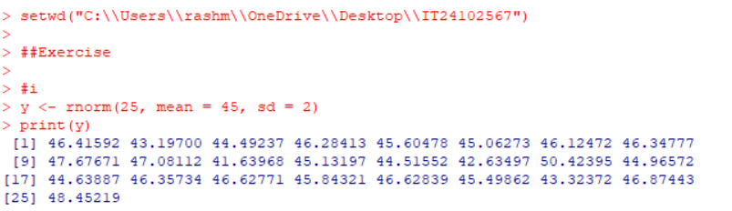

**2.**